**BHAVESH SHRIMALI**

**NetID: bshrima2**

**CEE 570: Finite Element Method**

**HW #4 Date: 03/06/2016**

**Problem 2:**

**(a)**

**4 (3,0)**

**3 (2,0)**

**2 (1,0)**

**1 (0,0)**

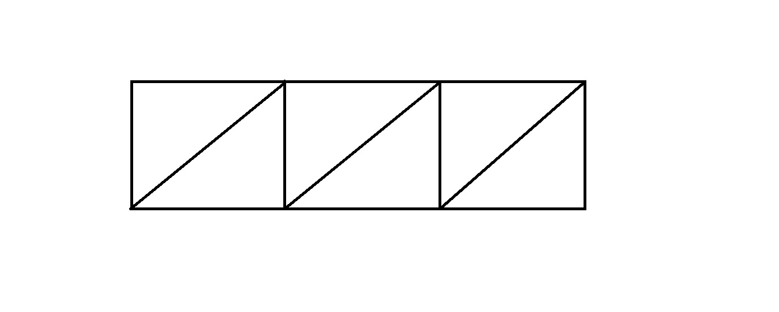**Results:**

**Element and Nodal Nomenclature considered for the problem**

**5 (3,1)**

**6 (2,1)**

**7 (1,1)**

**8 (0,1)**

**Deformed Configuration**

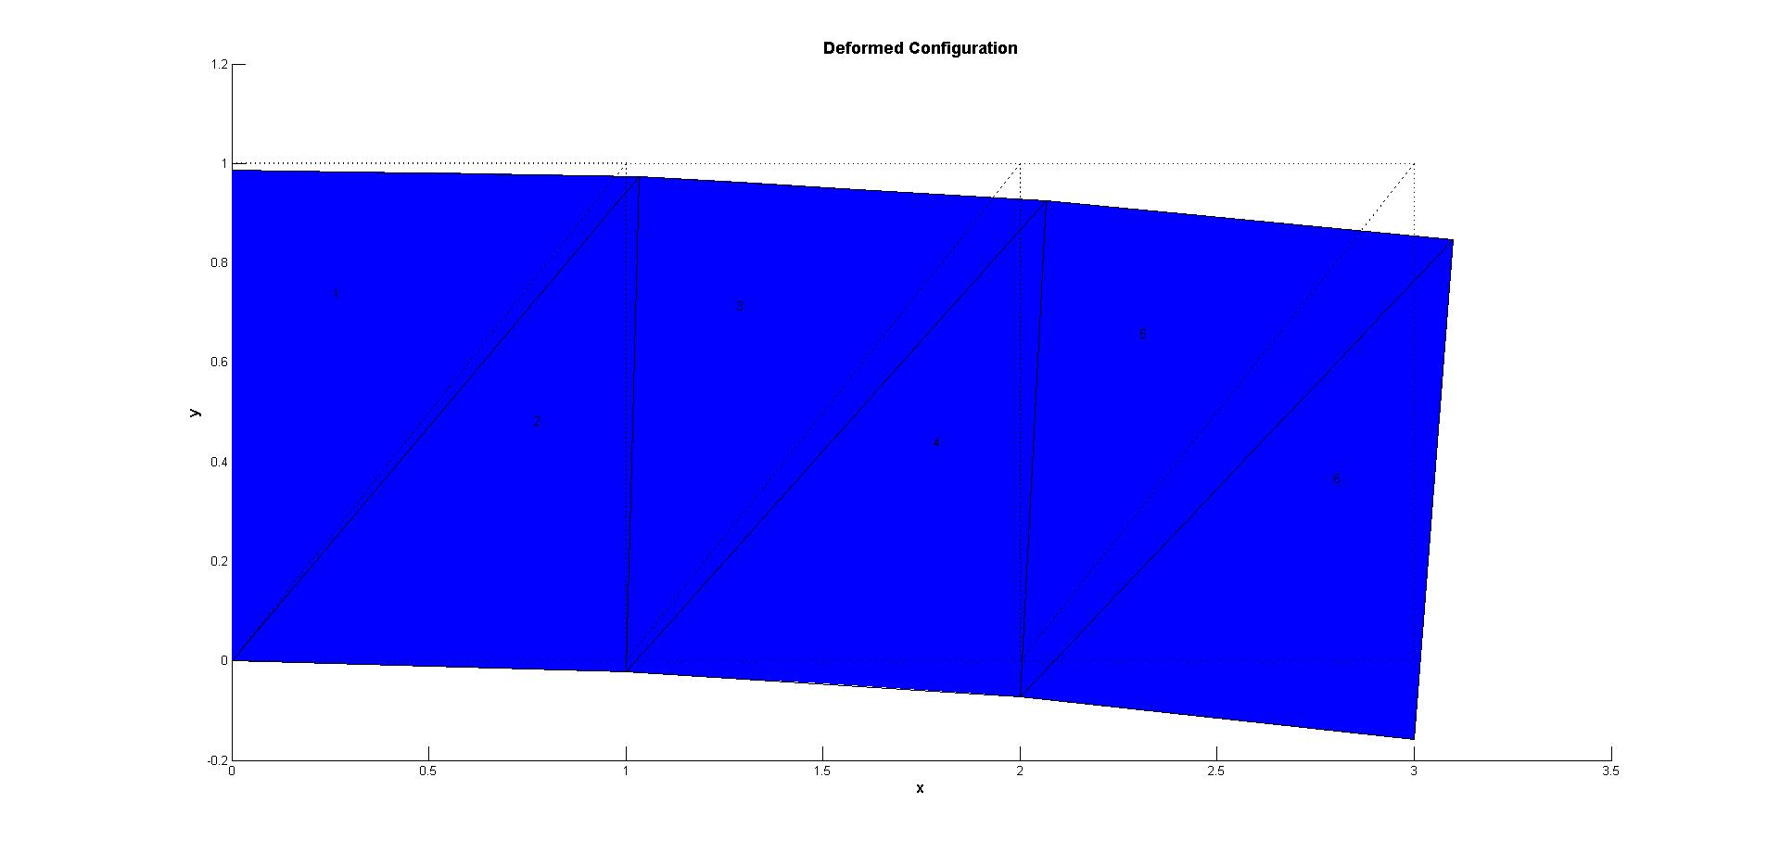

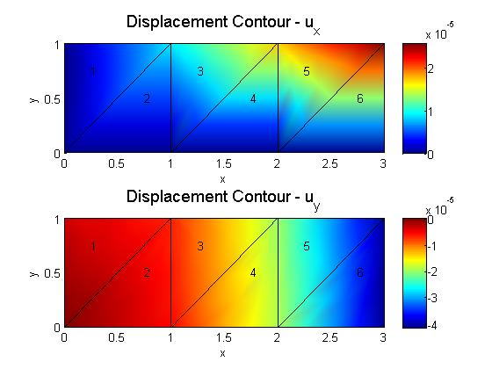

**Displacement Values:**

|  |  |  |
| --- | --- | --- |
| **Node #** | **Displacement in x (* 10-4)** | **Displacement in y (* 10-4)** |
| **1** | **0** | **0** |
| **2** | **0** | **-0.0568** |
| **3** | **0** | **-0.1889** |
| **4** | **0** | **-0.4132** |
| **5\*** | **0.2559** | **-0.4013** |
| **6** | **0.1718** | **-0.1979** |
| **7** | **0.09** | **-0.0682** |
| **8** | **0** | **-0.035** |

**\*The displacement of the top right node is highlighted.**

**2 (b):**

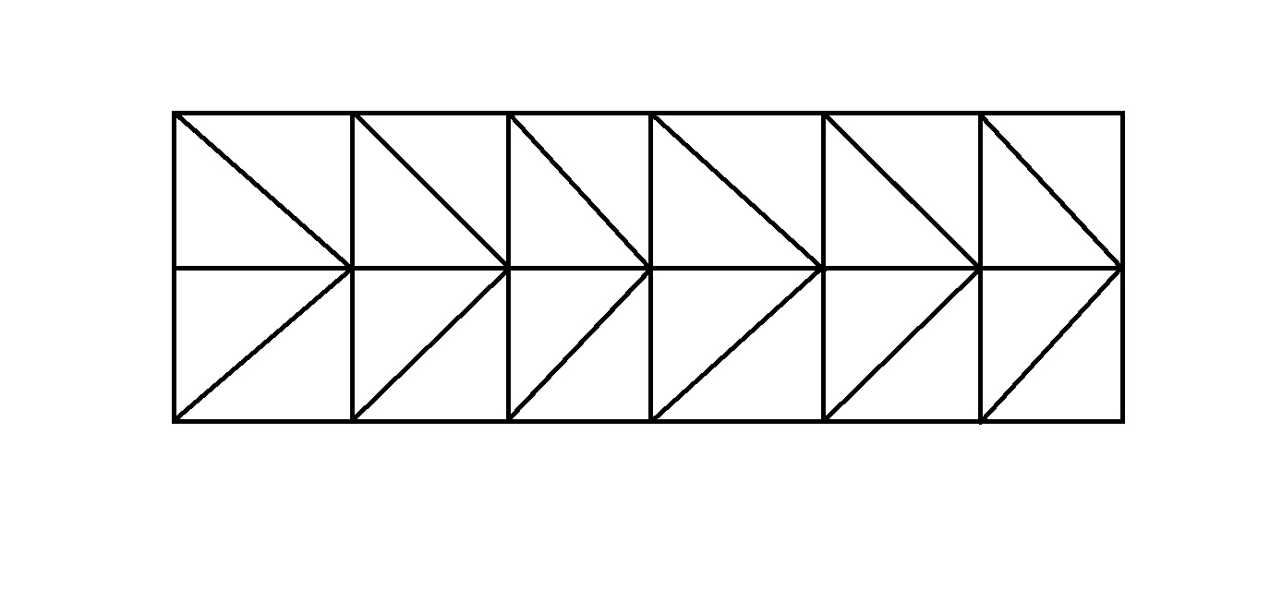

**Element and Nodal Nomenclature considered for the problem**

**21 (3,1)**

**20 (2.5,1)**

**19 (2,1)**

**18 (1.5,1)**

**17 (1,1)**

**16 (0.5,1)**

**15 (0,1)**

**9 (2.5,0.5)**

**13 (0.5,0.5)**

**11 (1.5,0.5)**

**8 (3,0.5)**

**12 (1,0.5)**

**14 (0,0.5)**

**10 (2,0.5)**

**7 (3,0)**

**6 (2.5,0)**

**4 (1.5,0)**

**2 (0.5,0)**

**1 (0,0)**

**3 (1,0)**

**5 (2,0)**

**Results:**

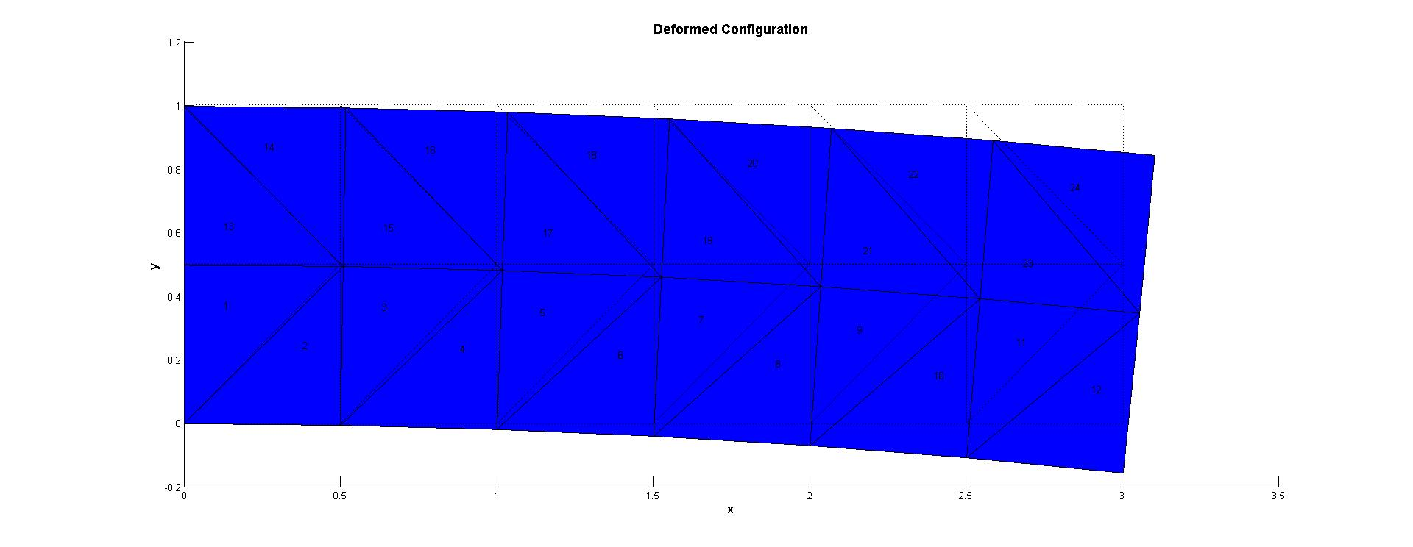

|  |  |  |
| --- | --- | --- |
| **Node #** | **Displacement in x (* 10-4)** | **Displacement in y (* 10-4)** |
| **1** | **0** | **0** |
| **2** | **0** | **-0.0195** |
| **3** | **0** | **-0.0666** |
| **4** | **0** | **-0.1442** |
| **5** | **0** | **-0.2525** |
| **6** | **0** | **-0.3916** |
| **7** | **0** | **-0.5678** |
| **8** | **0.193** | **-0.5615** |
| **9** | **0.1577** | **-0.3957** |
| **10** | **0.1251** | **-0.2569** |
| **11** | **0.0935** | **-0.1483** |
| **12** | **0.0624** | **-0.0706** |
| **13** | **0.0312** | **-0.024** |
| **14** | **0** | **-0.0122** |
| **15** | **0** | **-0.0155** |
| **16** | **0.0628** | **-0.0352** |
| **17** | **0.1246** | **-0.0823** |
| **18** | **0.1863** | **-0.1602** |
| **19** | **0.2478** | **-0.2691** |
| **20** | **0.3087** | **-0.4087** |
| **21\*** | **0.3694** | **-0.579** |

**\*The displacement of the top right node is highlighted.**

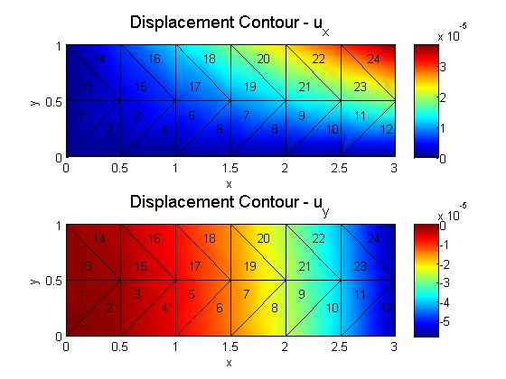

**Plot of u vs log(1/h) for x and y displacement values {normalized with exact values}:**

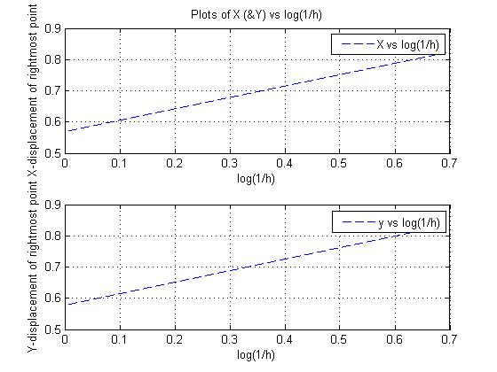

**Matlab Code for Plotting:**

%Plot of u (&v) vs log(1/h) for different values of h:

x_plot=[log(1) log(2)];

u_plot=[0.2559 0.3694]/0.45;

v_plot=[-0.4013 -0.579]/(-0.69375);

subplot(2,1,1)

plot(x_plot,u_plot,'--');

grid on

xlabel('log(1/h)');

ylabel('X-displacement of rightmost point');

legend('X vs log(1/h)');

title('Plots of X (&Y) vs log(1/h)');

subplot(2,1,2)

plot(x_plot,v_plot,'--');

grid on

xlabel('log(1/h)');

ylabel('Y-displacement of rightmost point');

legend('y vs log(1/h)');

**Problem 3:**

**Solution to 2 (a) using quads:**

**Element and Nodal Nomenclature considered for the problem**

**8 (0, 1)**

**7 (1, 1)**

**6 (2, 1)**

**5 (3, 1)**

**y**

**x**

**1 (0, 0)**

**4 (3, 0)**

**3 (2, 0)**

**2 (1, 0)**

**Nodal Displacements:**

|  |  |  |
| --- | --- | --- |
| **Node #** | **Displacement in x (* 10-4)** | **Displacement in y (* 10-4)** |
| **1** | **0** | **0** |
| **2** | **0** | **-0.0672** |
| **3** | **0** | **-0.2687** |
| **4** | **0** | **-0.6045** |
| **5\*** | **0.403** | **-0.6213** |
| **6** | **0.2687** | **-0.2854** |
| **7** | **0.1343** | **-0.084** |
| **8** | **0** | **-0.0168** |

**\*The displacement of top right node is highlighted.**

**Deformed Configuration**



**Contour Plots:**



**Solution to 2(b) using quads:**

**Element and Nodal Nomenclature considered for the problem**

**21 (3, 1)**

**20 (2.5, 1)**

**19 (2, 1)**

**18 (1.5, 1)**

**17 (1, 1)**

**16 (0.5, 1)**

**15 (0, 1)**

**y**

**8 (3, 0.5)**

**10 (2, 0.5)**

**9 (2.5, 0.5)**

**11 (1.5, 0.5)**

**14 (0, 0.5)**

**13 (0.5, 0.5)**

**12 (1, 0.5)**

**7 (3, 0)**

**6 (2.5, 0)**

**5 (2, 0)**

**4 (1.5, 0)**

**1 (0, 0)**

**3 (1, 0)**

**2 (0.5, 0)**

**x**

**Results:**

|  |  |  |
| --- | --- | --- |
| **Node #** | **Displacement in x (* 10-4)** | **Displacement in y (* 10-4)** |
| **1** | **0** | **0** |
| **2** | **0** | **-0.0182** |
| **3** | **0** | **-0.0729** |
| **4** | **0** | **-0.164** |
| **5** | **0** | **-0.2915** |
| **6** | **0** | **-0.4551** |
| **7** | **0** | **-0.6558** |
| **8** | **0.22** | **-0.6599** |
| **9** | **0.1825** | **-0.46** |
| **10** | **0.1458** | **-0.2961** |
| **11** | **0.1093** | **-0.1685** |
| **12** | **0.0729** | **-0.0774** |
| **13** | **0.0364** | **-0.0228** |
| **14** | **0** | **-0.0046** |
| **15** | **0** | **-0.0182** |
| **16** | **0.0729** | **-0.0364** |
| **17** | **0.1457** | **-0.0911** |
| **18** | **0.2186** | **-0.1822** |
| **19** | **0.2915** | **-0.3098** |
| **20** | **0.3641** | **-0.4739** |
| **21\*** | **0.4356** | **-0.673** |

**\*The displacement of the top right node is highlighted.**

**Deformed Configuration:**

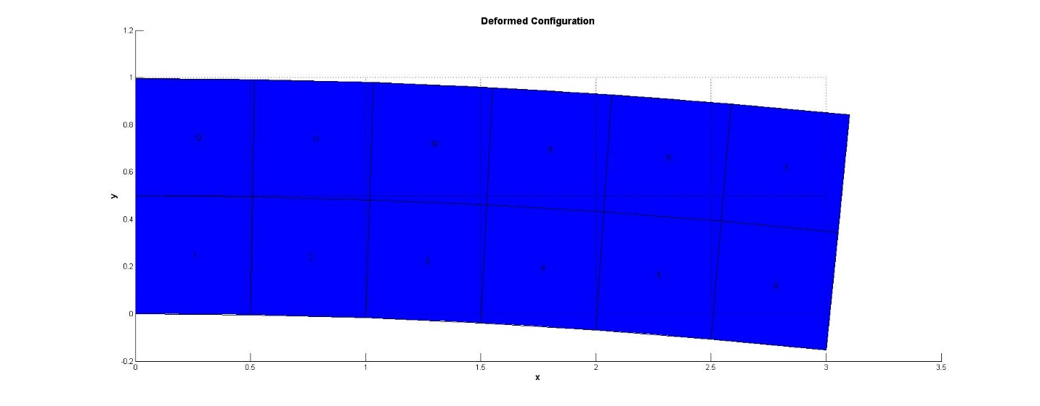

**Contour Plots:**

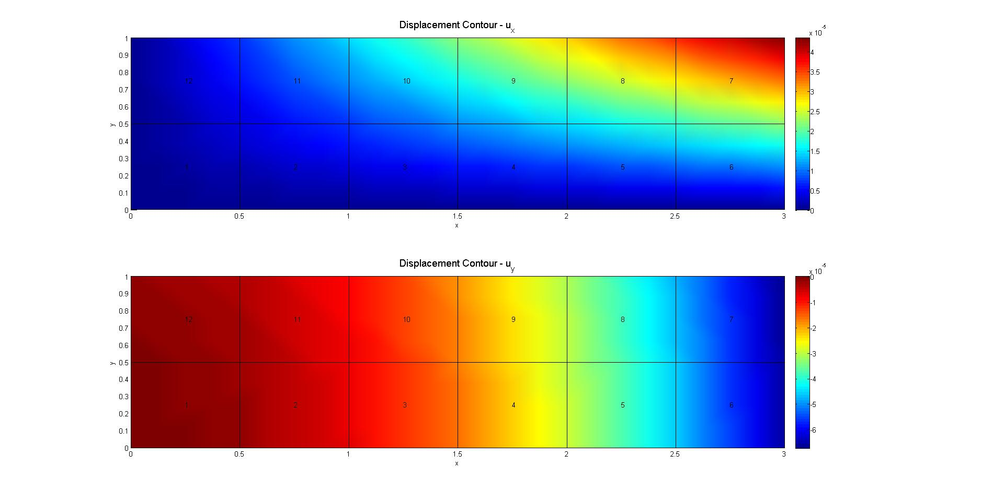

**Plot of u vs log (1/h) for x and y displacement values {normalized with exact values}:**



**Problem 3(d): Plane Strain**

For the plane strain condition, the displacement values obtained for the case of 12 elements is as follows:

|  |  |  |
| --- | --- | --- |
| **Node #** | **Displacement in x (* 10-4)** | **Displacement in y (* 10-4)** |
| **1** | **0** | **0** |
| **2** | **0** | **-0.017** |
| **3** | **0** | **-0.0682** |
| **4** | **0** | **-0.1534** |
| **5** | **0** | **-0.2727** |
| **6** | **0** | **-0.4257** |
| **7** | **0** | **-0.6135** |
| **8** | **0.206** | **-0.6188** |
| **9** | **0.1708** | **-0.4318** |
| **10** | **0.1364** | **-0.2784** |
| **11** | **0.1023** | **-0.1591** |
| **12** | **0.0682** | **-0.0739** |
| **13** | **0.0341** | **-0.0227** |
| **14** | **0** | **-0.0057** |
| **15** | **0** | **-0.0227** |
| **16** | **0.0682** | **-0.0398** |
| **17** | **0.1364** | **-0.0909** |
| **18** | **0.2045** | **-0.1761** |
| **19** | **0.2727** | **-0.2955** |
| **20** | **0.3406** | **-0.449** |
| **21\*** | **0.4075** | **-0.6353** |

**\*The displacement of the top right node is highlighted:**

**Deformed Configuration:**

**Contour Plots:**



**Part (ii)**

For the plane strain condition, the displacement values obtained for the case of 3 elements is as follows:

|  |  |  |
| --- | --- | --- |
| **Node #** | **Displacement in x (* 10-4)** | **Displacement in y (* 10-4)** |
| **1** | **0** | **0** |
| **2** | **0** | **-0.0625** |
| **3** | **0** | **-0.25** |
| **4** | **0** | **-0.5625** |
| **5\*** | **0.375** | **-0.5833** |
| **6** | **0.25** | **-0.2708** |
| **7** | **0.125** | **-0.0833** |
| **8** | **0** | **-0.0208** |

**\*The displacement of the top right node is highlighted.**



**Contour Plot:**



**Using Triangular Elements:**

Using triangular elements, and keeping number of elements equal to 24, the following results were obtained for the plane strain condition:

|  |  |  |
| --- | --- | --- |
| **Node #** | **Displacement in x (* 10-4)** | **Displacement in y (* 10-4)** |
| **1** | **0** | **0** |
| **2** | **0** | **-0.0185** |
| **3** | **0** | **-0.0624** |
| **4** | **0** | **-0.1348** |
| **5** | **0** | **-0.2357** |
| **6** | **0** | **-0.3654** |
| **7** | **0** | **-0.5302** |
| **8** | **0.1804** | **-0.525** |
| **9** | **0.1474** | **-0.3706** |
| **10** | **0.1168** | **-0.2411** |
| **11** | **0.0873** | **-0.1399** |
| **12** | **0.0582** | **-0.0674** |
| **13** | **0.0291** | **-0.024** |
| **14** | **0** | **-0.0132** |
| **15** | **0** | **-0.0194** |
| **16** | **0.0586** | **-0.038** |
| **17** | **0.1162** | **-0.0819** |
| **18** | **0.1737** | **-0.1546** |
| **19** | **0.2311** | **-0.2561** |
| **20** | **0.2879** | **-0.3864** |
| **21\*** | **0.3452** | **-0.5459** |

**\*The displacement of the top right node is highlighted.**





* **For the case of triangular elements, and when the number of elements is equal to 3, the following results were obtained.**

|  |  |  |
| --- | --- | --- |
| **Node #** | **Displacement in x (* 10-4)** | **Displacement in y (* 10-4)** |
| **1** | **0** | **0** |
| **2** | **0** | **-0.0557** |
| **3** | **0** | **-0.1807** |
| **4** | **0** | **-0.3918** |
| **5\*** | **0.2395** | **-0.3824** |
| **6** | **0.1618** | **-0.1922** |
| **7** | **0.0861** | **-0.0693** |
| **8** | **0** | **-0.0389** |

**\*The displacement of the top right node is highlighted.**



**Contour Plot:**



**Summary of the tabulated values of displacement of the top right node for Plane Stress and Plane Strain cases:**

|  |  |  |  |  |
| --- | --- | --- | --- | --- |
| **Case** | **Element Type** | **# of Elements** | **Ux (*10-4)** | **Uy (10-4)** |
| **Plane Stress** | **Triangular** | **6** | **0.2559** | **-0.4013** |
| **24** | **0.3694** | **-0.579** |
| **Quadrilateral** | **3** | **0.403** | **-0.6213** |
| **12** | **0.4356** | **-0.673** |
| **Plane Strain** | **Triangular** | **6** | **0.2395** | **-0.3824** |
| **24** | **0.3452** | **-0.5459** |
| **Quadrilateral** | **3** | **0.375** | **-0.5833** |
| **12** | **0.4075** | **-0.6353** |

**The input files used for the assignment are appended below:**

**For Plane Strain:**

1. **Triangular Elements (# of Elements = 6)**

% Mesh Nodal Coordinates

NodeTable = [0 0

1 0

2 0

3 0

3 1

2 1

1 1

0 1];

numnp = length(NodeTable);

% Mesh Element Connectivities

ix = [1 7 8 0 1

1 2 7 0 1

2 6 7 0 1

2 3 6 0 1

3 5 6 0 1

3 4 5 0 1

];

nen = 4;

numel = 6;

% Mesh Boundary Conditions and Loads

BCLIndex = [6 1]';

NodeBC = [1 1 0

1 2 0

2 1 0

3 1 0

4 1 0

8 1 0

];

NodeLoad = [5 1 5];

% Mesh Material Properties

young = 10e5;

pois = .25;

thick = 1;

PSPS = 'n';

MateT = [young pois thick];

FEA_Program

1. **Triangular Elements (# of Elements = 24)**

% Mesh Nodal Coordinates

NodeTable = [0 0

0.5 0

1 0

1.5 0

2 0

2.5 0

3 0

3 0.5

2.5 0.5

2 0.5

1.5 0.5

1 0.5

0.5 0.5

0 0.5

0 1

0.5 1

1 1

1.5 1

2 1

2.5 1

3 1];

numnp = length(NodeTable);

% Mesh Element Connectivities

ix = [1 13 14 0 1

1 2 13 0 1

2 12 13 0 1

2 3 12 0 1

3 11 12 0 1

3 4 11 0 1

4 10 11 0 1

4 5 10 0 1

5 9 10 0 1

5 6 9 0 1

6 8 9 0 1

6 7 8 0 1

13 15 14 0 1

13 16 15 0 1

12 16 13 0 1

12 17 16 0 1

11 17 12 0 1

11 18 17 0 1

10 18 11 0 1

10 19 18 0 1

9 19 10 0 1

9 20 19 0 1

8 20 9 0 1

8 21 20 0 1

];

nen = 4;

numel = 24;

% Mesh Boundary Conditions and Loads

BCLIndex = [10 2]';

NodeBC = [1 1 0

1 2 0

2 1 0

3 1 0

4 1 0

5 1 0

6 1 0

7 1 0

14 1 0

15 1 0];

NodeLoad = [8 1 3.75

21 1 3.125];

% Mesh Material Properties

young = 10e5;

pois = .25;

thick = 1;

PSPS = 'n';

MateT = [young pois thick];

FEA_Program

1. **Quadrilateral Elements (# of elements = 3)**

% Mesh Nodal Coordinates

NodeTable = [0 0

1 0

2 0

3 0

3 1

2 1

1 1

0 1];

numnp = length(NodeTable);

% Mesh Element Connectivities

ix = [1 2 7 8 1

2 3 6 7 1

3 4 5 6 1];

nen = 4;

numel = 3;

% Mesh Boundary Conditions and Loads

BCLIndex = [6 1]';

NodeBC = [1 1 0

1 2 0

2 1 0

3 1 0

4 1 0

8 1 0];

NodeLoad = [5 1 5];

% Mesh Material Properties

young = 10e5;

pois = .25;

thick = 1;

PSPS = 'n';

MateT = [young pois thick];

FEA_Program

1. **Modification in the Elas_2D file:**

if PSPS == 's' %Plane Stress

Dmat = ElemE/(1-Elemv^2)*[1 Elemv 0; Elemv 1 0; 0 0 (1-Elemv)/2];

else %Plane Strain

Dmat = ElemE/((1+Elemv)*(1-2*Elemv))*[1-Elemv Elemv 0;Elemv 1-Elemv 0;0 0 (1-2*Elemv)/2];

end

if nel == 4

Bmat = [Qxy(1,1) 0 Qxy(1,2) 0 Qxy(1,3) 0 Qxy(1,4) 0

0 Qxy(2,1) 0 Qxy(2,2) 0 Qxy(2,3) 0 Qxy(2,4)

Qxy(2,1) Qxy(1,1) Qxy(2,2) Qxy(1,2) Qxy(2,3) Qxy(1,3) Qxy(2,4) Qxy(1,4)

];

else

Bmat= [Qxy(1,1) 0 Qxy(1,2) 0 Qxy(1,3) 0

0 Qxy(2,1) 0 Qxy(2,2) 0 Qxy(2,3)

Qxy(2,1) Qxy(1,1) Qxy(2,2) Qxy(1,2) Qxy(2,3) Qxy(1,3)];

end

1. **Modification in the shp_2l.m file:**

elseif nel == 4

% shp(i,j). j = denotes the node number,

% i = 1, derivative w.r.t r

% i = 2, derivative w.r.t s

% i = 3, shape funtion

clear shp

syms xc eta real

shp(3,1)=0.25*(1-xc)*(1-eta);

shp(1,1) = diff(shp(3,1),xc);

shp(2,1) = diff(shp(3,1),eta);

shp(3,2) = 0.25*(1+xc)*(1-eta);

shp(1,2) = diff(shp(3,2),xc);

shp(2,2) = diff(shp(3,2),eta);

shp(3,3) = 0.25*(1+xc)*(1+eta);

shp(1,3) = diff(shp(3,3),xc);

shp(2,3) = diff(shp(3,3),eta);

shp(3,4) = 0.25*(1-xc)*(1+eta);

shp(1,4) = diff(shp(3,4),xc);

shp(2,4) = diff(shp(3,4),eta);

xc=r;

eta=s;

shp=double(subs(shp));

1. **Quadrilateral Elements (# of elements = 12):**

% Mesh Nodal Coordinates

NodeTable = [0 0

0.5 0

1 0

1.5 0

2 0

2.5 0

3 0

3 0.5

2.5 0.5

2 0.5

1.5 0.5

1 0.5

0.5 0.5

0 0.5

0 1

0.5 1

1 1

1.5 1

2 1

2.5 1

3 1

];

numnp = length(NodeTable);

% Mesh Element Connectivities

ix = [1 2 13 14 1

2 3 12 13 1

3 4 11 12 1

4 5 10 11 1

5 6 9 10 1

6 7 8 9 1

8 21 20 9 1

9 20 19 10 1

10 19 18 11 1

11 18 17 12 1

12 17 16 13 1

13 16 15 14 1

];

nen = 4;

numel = 12;

% Mesh Boundary Conditions and Loads

BCLIndex = [10 2]';

NodeBC = [1 1 0

1 2 0

2 1 0

3 1 0

4 1 0

5 1 0

6 1 0

7 1 0

14 1 0

15 1 0

];

NodeLoad = [8 1 3.75

21 1 3.125];

% Mesh Material Properties

young = 10e5;

pois = .25;

thick = 1;

PSPS = 'n';

MateT = [young pois thick];

1. **Calculation of Nodal Forces for Problem #2:**

clc;

%Calculation of the nodal forces for Problem#2

%Since we know that the shape function varies linearly between two

%nodes we can directly carry out the integrals.

syms y

f=15*y;

% 1) Using Mesh 1

N=[1-y y];

f_nodal=int(N'*f,y,0,1);

% 2) Using Mesh 2

N12=y*2;N11=2*(0.5-y);

N21=2*(1-y);N22=2*(y-0.5);

N1=[N11 N12];

N2=[N21 N22];

f1_nodal=int(N1'*f,y,0,0.5);

f2_nodal=int(N2'*f,y,0.5,1);